**DAY 2**

**VOIP:**

Task 1: setting up a basic voip network

Build the following network with 4 IP phone connected to the switch. Make sure all the IP phone get a IP address from the dhcp automatically. The dhcp is configured in the router. Configure so that there can be a maximum of 10 extensions and 10 phones that can be connected in the network given below. Call all the IP phones and check if the call is routed to the indented phone.

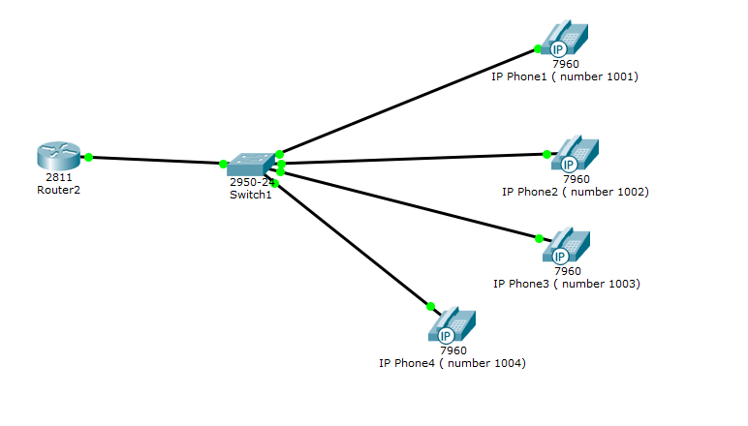

Task 2: setting up an advanced voip network. (next page)

Build the following network and make sure that the phone can call the phone on the other networks.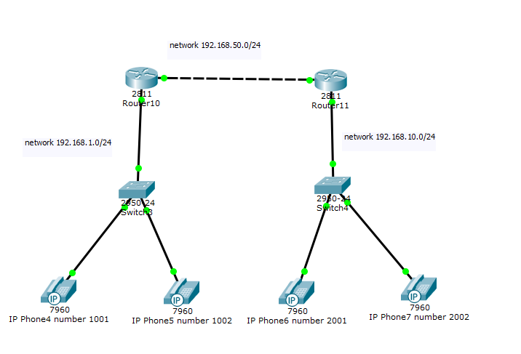

**VPN:**

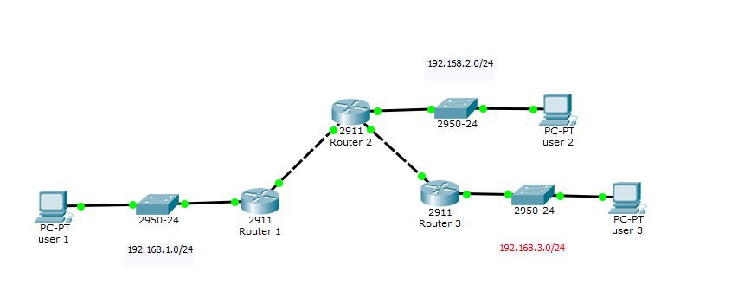

Configure the network given above and perform the tasks given below:

* Enable security features on all the 3 routers
* Configure IPsec Parameters between Router 1 and Router 3
* Configure IPsec Parameters between Router 2 and Router 4
* Verify the 2 IPSEC connection

**RADIUS:**

1. **Wireless**

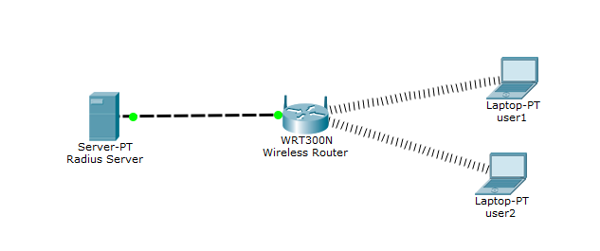

Build the above lab. Configure the Radius server with 2 users “user1” and “user2”. Turn on WPA-2 Enterprise encryption for the above network setup. Configure DHCP in the wireless router. The two users must connect to the network automatically. To test if the laptops connect automatically, power off the laptop, then turn it on again and see if the laptop connects to the wireless router automatically.

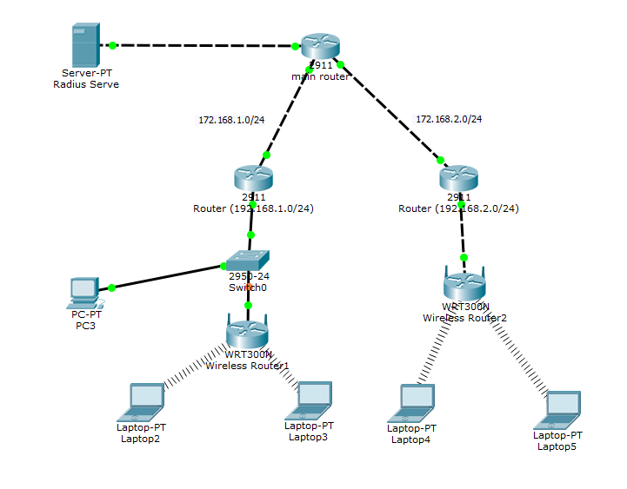

Lab created by Rugved Jakka.